|  |  |
| --- | --- |
| Sample Use | Course Project |
| Prepared by | Jaimey Foti |
| Prepared on | 14 February 2019 |

Santander Cycles

Customer User Manual

London, UK

Processes

Version 1.0 – February 2019

14 February 2019

Revision History

|  |  |  |
| --- | --- | --- |
| Date of revision | Description of revision | Revised by |
| 14 February 2019 | First draft course project – original document | Jaimey Foti |

Contents

Overview of the service 4

Quick-Start Guide 4

Pricing 4

Hiring 4

Returning the Bike 5

Using the Santander App 5

Setting up the App 5

Planning your Journey 5

Hiring the bike 6

Using the Santander Docking Station Terminal 6

Using the Santander Cycles App by TFL 6

Using the registered Mobile Phone or Customer Card 6

Calling 6

Unlocking the Bike 6

Checking the bike 6

Saddle 6

Tires 7

Brakes 7

Bell 7

Riding safely 7

Returning the Bike 7

For tourists: places to see on a bike 7

For Commuters: Membership Key 8

Troubleshooting 8

Error codes 8

Useful contact numbers 9

# Overview of the service

Santander Cycles provides cycle hire for tourists and commuters in the UK. The purpose of the document is to explain how to access, use and return the cycles in the London. It will cover steps to use the automated self-service to choose and pay for your bike, unlock the bike and return the bike after use. It will provide people with advice on how to ride and the rules, regulation and tips, for example, riding on the left side of the road.

# Quick-Start Guide

Read the following quick start guide for price and hiring instructions.

## Pricing

There are two pricing options available when hiring. Both rates allow the user to cycle from one docking station terminal to another within a 30-minute timeframe. Late returns cost an extra £2 per hour.

|  |  |
| --- | --- |
| **Daily** | **Yearly** |
| £2 for 24 hours. Make as many 30 minute journeys as you like within 24 hours. | £90 to use the bikes all year round |

Tip: You can view the bikes and spaces available online. There are more than 11,500 bikes at over 750 docking stations across London. You can view the docking stations and bikes available at <https://tfl.gov.uk/modes/cycling/santander-cycles/find-a-docking-station>

## Hiring

Follow the below instructions to hire from a Santanders terminal.

1. Go to the nearest docking station terminal with your debit or credit card
2. Choose 'Hire a cycle'
3. Follow the on-screen instructions and take the printed release code
4. Choose your bike situated at one of the docking points.
5. Enter your five-digit release code into the docking point's keypad and pull the bike out when the green light appears
6. Adjust the saddle height, check the tyres, brakes and bell
7. You are ready to ride



Tip: Take a moment to read about safer cycling at the terminal

## Returning the Bike

When you arrive at the docking station, follow these steps to avoid being charged again.

1. Push the bike firmly into an empty docking point
2. Wait for the green light, which will show that the bike is securely docked.

# Using the Santander App

Use the Santander Cycle app to view online. The app is for the individual phone user on the go. You can pay for and get confirmation codes, set up your credit card details, choose locations and create journeys all in the one app. Save time paying by ticking the auto pay box when registering. The Santander App will allow you to find Cycle availability in real-time. Just remember to charge your phone the day before.



Tip: Santander docking stations are open from 9am – 5pm daily.

See live docking station information, availability and an interactive map, find your nearest or favourite docking stations, and search with a wider range of criteria - including landmarks.

## Setting up the App

1. Access the Play Store or App Store.
2. 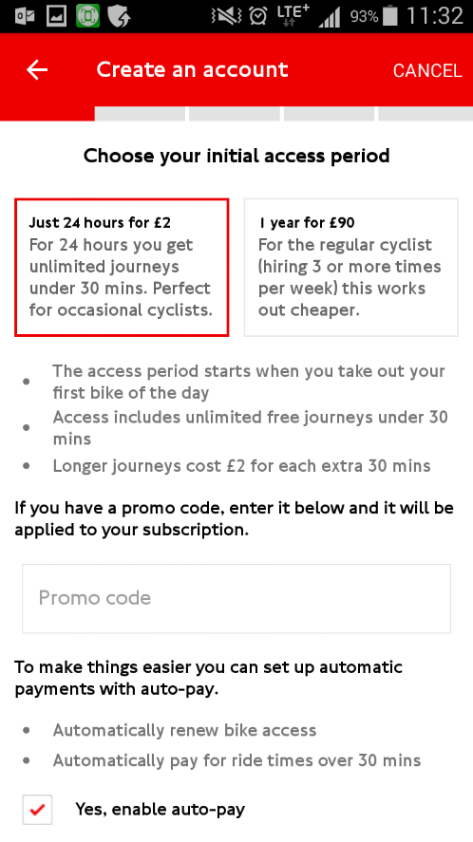Download the Santander Cycles app by TFL.
3. Open the app once it has finished downloading
4. Press Create an Account
5. Choose your initial access period
6. Enter a promo code if you have one
7. Tick or untick auto-pay
8. Press Next
9. Enter your personal details
10. Enter your email address and password
11. Choose a security question
12. Enter an answer to the security question
13. Press Next
14. Enter your Credit Card number
15. Press Next
16. Confirm all details are correct
17. Enter in your Credit Card Expiration Date and CVV

## Planning your Journey

1. Use the map to view the locations, spaces and bikes available
2. Press the three stripes to open the menu
3. Press Plan a Journey
4. Tap to specify the start point
5. Enter the location in the search bar
6. Enter the start point in the search location and choose the starting point in the below search results.
7. Press the next field to specify the end point
8. Enter the location in the search bar
9. Enter the start point in the search location and choose the starting point in the below search results.
10. Press Plan my journey
11. The following is a route where you can pick up the car and drop it off.
12. Choose Easy for a quieter route, Moderate or Fast for a more direct but busier route.



Tip: London’s cycle network [is always expanding](https://tfl.gov.uk/modes/cycling/routes-and-maps/new-cycle-routes). There are now [7 Quietways](https://tfl.gov.uk/modes/cycling/routes-and-maps/quietways?intcmp=21098) for those who want to cycle on lower traffic areas. The more direct routes are the busier [8 Cycle Superhighways](https://tfl.gov.uk/modes/cycling/routes-and-maps/cycle-superhighways).

# Hiring the bike

## Using the Santander Docking Station Terminal

1. Go to the docking station terminal with your debit or credit card and touch the screen to begin.
2. Choose 'Hire a cycle'
3. Follow the on-screen instructions and take the printed release code
4. Choose your bike situated at one of the docking points.
5. Enter your five-digit release code into the docking point's keypad and pull the bike out when the green light appears

## Using the Santander Cycles App by TFL

1. Enter the bike number
2. Receive a 4-digit code in the app
3. Enter the code in the bike computer, press OK and the bike will unlock

## Using the registered Mobile Phone or Customer Card

1. Enter your registered mobile number and 6-digit PIN into the bike’s computer

**OR** Tap your customer card on the bike’s computer and enter your 6-digit PIN and the bike will unlock

## Calling

1. Call 02081669851 for Milton Keynes and Brunel or 02922481736 for Swansea
2. Follow the prompts to make payment
3. Wait for the 4-digit code
4. Enter the 4-digit code in the bike computer and the bike will unlock

## Unlocking the Bike

1. Slide the cable lock out of the front wheel
2. Secure the cable lock in the holder

# Checking the bike

Before getting on your bike, check the saddle, tires, brakes and bell are fully functional.

If the bike is unsafe to ride, please let us know it needs repairing by returning the bike to the dock. Press the 'Fault' button on the docking point within 10 seconds of docking it. Turn the saddle backwards to show others that it needs repairing. Get a new release code at the terminal. There is no further charge for this, provided your access period is still valid, choose another cycle.

## Saddle

Check the lower bottom bracket to correct the step-through height.

Adjust the saddle using the ‘one-handed’ seat clamp

## Tires

Check the tires by squeezing the tires between thumb and forefinger. If the tires appear loose, or if the tire is unable to support your weight, consider the bike faulty.

## Brakes

Squeeze and hold each handlebar brake

Alternate squeezing each handle while checking the brake pads on each tire.

## Bell

Locate the bell on the right handle and ring it to ensure the bell can be heard.

# Riding safely

Read about safer cycling at the terminal

Use the app to check the spaces available at your next location.

Stop at all red traffic lights or you may be fined.

Keep a door’s width away from parked cars.

Stick to the designated cycling Quietways, Superhighways and backstreets if you are an inexperienced rider.

Make eye contact with drivers.

Indicate with your hands when you are turning left or right.

Cycle on cycleways only. Do not cycle on pavement and pedestrian areas.

Wear bright clothes.

The bikes have lights that come on automatically when you start pedalling.

Helmets are not necessary but for your own safety and your child’s you may consider buying one.

Educate yourself on London’s [tips and advice](https://tfl.gov.uk/modes/cycling/cycling-advice?intcmp=47656).

## Returning the Bike

When you arrive at the docking station, follow these steps to avoid being charged for a late return.

1. Push the bike firmly into an empty docking point
2. Wait for the green light, which will show that the bike is securely docked. If you don't get a green light, call 03432226666.

# For tourists: places to see on a bike

Depending on your tastes, there are a range of Cycleways and journeys to choose from. Here are just a few options:

Borough to Covent Garden

Covent Garden to Trafalgar Square

Trafalgar Square to Hyde Park

Hyde Park to Portobello Road

Camden Market to Camden Passage

Camden Passage to Exmouth Market

Exmouth Market to Spitalfields Market

Ladbroke Grove to Holland Park

Holland Park to Kyoto Gardens

Kyoto Gardens to Hyde Park

Hyde Park to Chelsea Physic Garden

# For Commuters: Membership Key

Regular commuters can become members using the Santander Cycles app and by setting up an online account.

Step 1: Register with the Santander Cycles App by TFL and choose the yearly payment method (see page 5). You now have access to release codes direct to your smartphone.

Step 2: Register for a key online at <https://santandercycles.tfl.gov.uk/Registration>

Step 3: Click Order a New Key, choose payment method and enter personal details

Step 4: Make the purchase (£3 per key). You can make extra for family members under the one web account

Step 5: Wait for your membership key to arrive in the mail

Step 6: Log in to your online web account to activate membership key

# Troubleshooting

Before contacting Santander Cycles, please see the below troubleshooting tips

## Error codes

**Can I leave my bike somewhere?**

Yes. There are over 750 docking stations across London where you can dock the bike. To utilise Santander Cycles effectively, aim to ride the bike to another docking station near the location or area you wish to visit within the 30 minute timeframe.

**My membership key is lost/stolen**

Call the Contact Centre on 0343 222 6666 so Santander Cycles can deactivate your membership key and organise a replacement.

**The bike is too large/small for my size.**

Adjust the height of the bike using the lower bottom bracket and the one-hand saddle clamp.

**Why am I overcharged?**

Santander Cycles charged 2 pounds for a full day, however each use during the day is limited to 30 minutes. To ensure you are not charged extra, aim to ride the bike to another docking station near the location or area you wish to visit within the 30 minute timeframe.

**How do I check out two bikes at once?**

The Santander Cycle app is for the individual phone user on the go. If you intend to pay for more than one user, you can use the kiosk to book up to four bikes with the same credit card.

**How do I make two separate payments with the app? I bought multiple codes and they don’t all work.**

The Santander Cycle app is for the individual phone user on the go. Use the kiosk to make multiple purchases.

**Help! I’m not back in time or I’m late returning my bike.**

You can continue to use the bike. If you are late, you can pay 2 extra once you return the bike. For Santander Cycle app users, you can tick the auto pay option.

**Why only 30 minutes? Can I get longer times?**

Santander Cycles is a premium cost-effective self-service bike-sharing scheme for short journeys allowing you to see wonderful spots around London. The 30 minutes time is why the bikes are so cost effective, by sharing your bike with fellow commuters and tourists who also get access between the best places in London.

**My bike is faulty. What should I do?**

1. Press the 'Fault' button on the docking point within 10 seconds of docking it.
2. Turn the saddle backwards to show others that it needs repairing.

## Useful contact numbers

For complaints and suggestions about our cycle hire scheme, please call our Contact Centre on 0343 222 6666.

|  |  |
| --- | --- |
| Contact | Phone |
| Santander Contact Centre | 0343 222 6666 |
| Milton Keynes & Brunel | 0208 166 9851 |
| Swansea | 0292 248 1736 |
| Business Enquiries | 0343 222 0066 |
|  |  |